Fulton County Health Department

700 E. Oak Street

Canton, IL 61520

309-647-1134, ext. 245

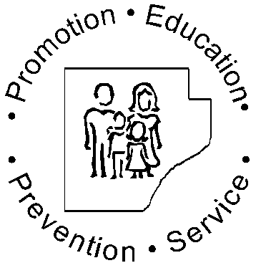

## Low Income Home Energy Assistance Program



Fulton County Health Department

Low Income Home Energy

Assistance Program

700. E. Oak Street

Canton, IL 61520

309-647-1134, ext. 245

### Low Income Home Energy Assistance

For many Fulton County households, energy costs place severe stress on the family’s budget. The Low Income Home Energy Assistance program (LIHEAP) is designed to assist eligible low-income households pay for energy services.

LIHEAP will provide a one-time benefit to eligible households to be used for energy assistance. The amount of the payment is determined by income, household size, fuel type and geographic location.

An overdue bill or cut-off notice is not required. You do not have to own your home or pay energy bills directly to be eligible for assistance. Your source of fuel does not have to be natural gas or electricity in order to receive assistance.

Reconnection assistance may be available if your household is disconnected from an energy source needed for heating and/or a delivered-fuel supplier has refused to deliver and the tank contains 25% or less.

Assistance for reconnection will only be provided to households that have made a good faith effort to maintain their energy services or can pay a portion of the reconnection fee.

Call the Fulton County Health Department

309-647-1134 Ext. 245

**QUESTIONS?**

Company Name

### How Does It Work?

Step 1: *Application*

Contact the Fulton County Health Department to apply.

The staff member who takes your application will help you understand:

* The program requirements
* The type of assistance available
* Your rights under the program

When you apply for assistance, bring the following with you:

* Proof of gross income from all household members for the 30-day period prior to the application date
* A copy of your current heat and electric bills (if you pay for home energy directly)
* Social Security cards for all household members
* If a member of your household receives TANF, you must bring their “Medical Eligibility Card”
* If you rent, bring proof of your rental agreement. It must state your monthly rent amount

Step 2: *Notification*

You will be notified of your eligibility status within 30 days. If you are eligible, you will be informed of the amount of assistance you can receive.

The Fulton County Health Department will also notify your energy provider of your participation in the program if you have an energy bill.

Step 3: *Payment*

If you are eligible, the Fulton County Health Department will make the appropriate payment to your energy provider(s).

## Who is Eligible?

You may be able to receive assistance under the Low Income Home Energy Assistance Program if your household’s combined income is at or below the levels shown in the chart below.

If you rent, and your heat and/or electric is included in the rent, then your rent must be greater than 30% of your income in order to be eligible to receive benefits.

|  |  |  |
| --- | --- | --- |
| Family Size | 150%  30 Day Income | 150% Annual Income |
| 1 | $1,459 | $17,505 |
| 2 | $1,966 | $23,595 |
| 3 | $2,474 | $29,685 |
| 4 | $2,981 | $35,775 |
| 5 | $3,489 | $41,865 |
| 6 | $3,996 | $47,955 |
| 7 | $4,504 | $53,045 |
| 8 | $5,011 | $60,135 |
| 9 | $5,519 | $66,225 |