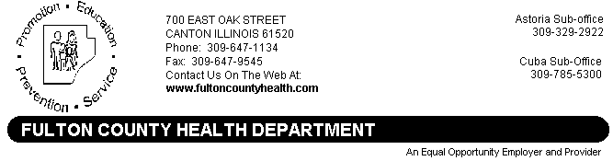
Date: August 31, 2015
To: Area Media
From: Damon Roberson, Administrator
Re: News Release for Immediate Release

FULTON COUNTY BIRD TESTS POSITIVE FOR WEST NILE VIRUS

The Fulton County Health Department has recently received notification from the Illinois Department of Public Health that a dead bird collected from Fulton County has tested positive for West Nile Virus (WNV) infection.

The bird was collected from the Farmington area on August 20, 2015 and was sent for testing. The Fulton County Health Department received notification on August 31, 2015 that the bird was found positive for West Nile Virus infection.
Illinois’ surveillance for West Nile virus began May 1 and includes laboratory tests on mosquitoes, dead birds, and the testing of sick horses and humans with West Nile-like disease symptoms. Citizens who observe a sick or dying bird should contact their local health department, which will determine if the bird is to be picked up for testing.
West Nile virus is transmitted through the bite of a mosquito that has picked up the virus. Most people with the virus have no clinical symptoms of illness, but some may become ill three to 14 days after the bite of an infected mosquito. Mosquitoes stay active until there is a hard freeze.
Only about two persons out of 10 who are bitten by an infected mosquito will experience any illness. Illness from West Nile is usually mild and includes fever, headache and body aches, but serious illness, such as encephalitis and meningitis, and death are possible. Persons older than 50 years of age have the highest risk of severe disease.
The best way to prevent West Nile disease or any other mosquito-borne illness is to reduce the number of mosquitoes around your home and to take personal precautions to avoid mosquito bites. Precautions include:
- Avoid being outdoors when mosquitoes are most active, especially between dusk and dawn. Use prevention methods whenever mosquitoes are present.
- When outdoors, wear shoes and socks, long pants and a long-sleeved shirt, and apply insect repellent that includes DEET, picaridin or oil of lemon eucalyptus according to label instructions. Consult a physician before using repellents on infants.
- Make sure doors and windows have tight-fitting screens. Repair or replace screens that have tears or other openings. Try to keep doors and windows shut, especially at night.
- Eliminate all sources of standing water that can support mosquito breeding, including water in bird baths, ponds, flowerpots, wading pools, old tires and any other receptacles. In communities where there are organized mosquito control programs, contact your municipal government to report areas of stagnant water in roadside ditches, flooded yards and similar locations that may produce mosquitoes.
The Fulton County Health Department will continue to conduct surveillance for indications of West Nile Virus activity until a hard frost, when mosquitoes die out for the season. Until then, if the weather is warm enough for summer-like clothing, individuals are encouraged to continue to take precautions and protect themselves from mosquito bites and West Nile Virus.

