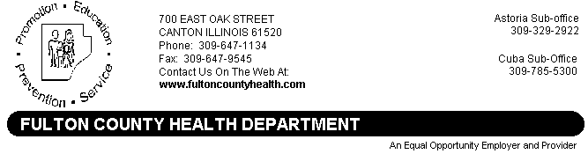
Date: August 19, 2015
To: Area Media
From: Damon Roberson, Administrator
Re: News Release for Immediate Release

FULTON COUNTY MOSQUITOES TEST POSITIVE FOR WEST NILE VIRUS
A pool of mosquitoes collected in Vermont, Illinois have been confirmed as testing positive for West Nile virus according to Damon Roberson, Administrator of the Fulton County Health Department. According to Roberson, the mosquitoes were collected and tested by the Miller-Hunt Virology Laboratory at Western Illinois University. The Fulton County Health Department is working in conjunction with Western Illinois University to trap and test mosquitoes in Fulton County.
Roberson says, “West Nile virus activity has been present in the state and we expected to see activity again this year. These findings should serve as a reminder to citizens to take precautions to prevent contracting this mosquito-borne disease.”
Illinois’ surveillance for West Nile virus began May 1 and includes laboratory tests on mosquitoes, dead crows and blue jays, and the testing of sick horses and humans with West Nile-like disease symptoms. Citizens who observe a sick or dying crow or blue jay should contact their local health department, which will determine if the bird can be sent for testing.
West Nile virus is transmitted through the bite of a mosquito that has picked up the virus by feeding on an infected bird. Most people with the virus have no clinical symptoms of illness, but some may become ill three to 14 days after the bite of an infected mosquito. The first human case in Illinois is not usually reported until July or later.
Only about two persons out of 10 who are bitten by an infected mosquito will experience any illness. Illness from West Nile is usually mild and includes fever, headache and body aches, but serious illness, such as encephalitis and meningitis, and death are possible. Persons older than 50 years of age have the highest risk of severe disease.
The best way to prevent West Nile disease or any other mosquito-borne illness is to reduce the number of mosquitoes around your home and to take personal precautions to avoid mosquito bites. Precautions include:
- Avoid being outdoors when mosquitoes are most active, especially between dusk and dawn. Use prevention methods whenever mosquitoes are present.
- When outdoors, wear shoes and socks, long pants and a long-sleeved shirt, and apply insect repellent that includes DEET, picaridin or oil of lemon eucalyptus according to label instructions. Consult a physician before using repellents on infants.
- Make sure doors and windows have tight-fitting screens. Repair or replace screens that have tears or other openings. Try to keep doors and windows shut, especially at night.
- Eliminate all sources of standing water that can support mosquito breeding, including water in bird baths, ponds, flowerpots, wading pools, old tires and any other receptacles. In communities where there are organized mosquito control programs, contact your municipal government to report areas of stagnant water in roadside ditches, flooded yards and similar locations that may produce mosquitoes.
Information about West Nile can be obtained by contacting the Fulton County Health Department at 647-1134 (Monday through Friday 8AM to 4PM). Information is also available at the Illinois Department of Public Health’s web site at www.idph.state.il.us/envhealth/wnv.htm; or people can call the West Nile Virus Hotline at 866-369-9710 Monday through Friday from 8 a.m. to 5 p.m.

