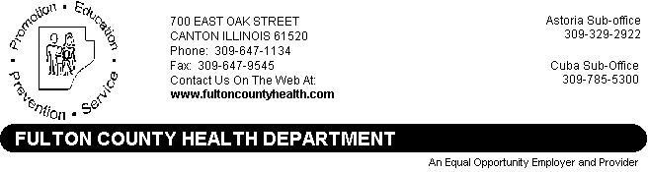

Agenda
Fulton County Board of Health Date: January 20, 2026
Fulton County Health Dept. Room # 103 7:00 PM Call Meeting to Order

- Approve Minutes –November
- Agenda Changes
- Public Comments
- Financial Reports – November & December
- New Business-

  - Approval Annual Report
  - Election of officers

I. Old Business –

- Division Reports
  - Family & Community Health Services – Amy Edwards
  - Environmental Health – Katie Lynn

- Administrators Report
- Presidents Report
- Executive Session
- Adjourn

